Nobel Laureates in Chemistry
(2000-2016)

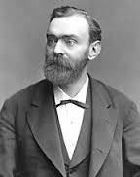

Alfred Nobel
Photo credit:
https://www.nobelprize.org/alfred_nobel/biographical/articles/life-work/

Introduction

“Home is where I work and I work everywhere” this is the famous quote by Alfred Nobel, the man who decided to give away all his wealth to society through Nobel Prizes.
From the beginning, Nobel prizes attracted public attention in a way that no other scientific award had. There is an interesting story of establishment of a Nobel Prize. It all began with a journalistic error. In 1888, A French newspaper mistakenly wrote that Alfred Nobel, inventor of dynamite, had died but it was his brother who had passed. He was crushed by the idea that he would be remembered as a “Merchant of Death”. In order to regain control of his legacy, he willed his fortune to create an award that would recognize people who had made positive contribution to mankind.
Nobel Prizes have been awarded for achievement in Physics, Chemistry, Literature, Medicine since 1901 Each Nobel Prize consist of a medal, personal citation and cash award.

Reference:
http://www.todayifoundout.com/index.php/2011/01/alfred-nobel-was-also-known-as-the-merchant-of-death/

Books:
Indian Nobel Laureates by Arun Anand
Alfred Nobel: Great personalities of world by Swati Upadhye

All facts and figures about Nobel prizes in Chemistry:

- 107 Nobel prizes have been awarded between 1901 and 2015.
- 63 chemistry prizes have been given to one laureate only.
- 4 women have been awarded the chemistry prizes so far.
- 1 person Frederick Sanger has been awarded the chemistry Prize twice in 1958 and in 1980.
- 35 years was the age of youngest chemistry laureate ever. Frederic Joliot, who was awarded the Nobel Prize in 1935.
- 85 years was the age of oldest chemistry laureate, John B Fenn, when he was awarded the chemistry prize in 2002
Reference:
https://www.nobelprize.org/nobel_prizes/facts/chemistry/

Chemistry Nobel Laureate (2016)
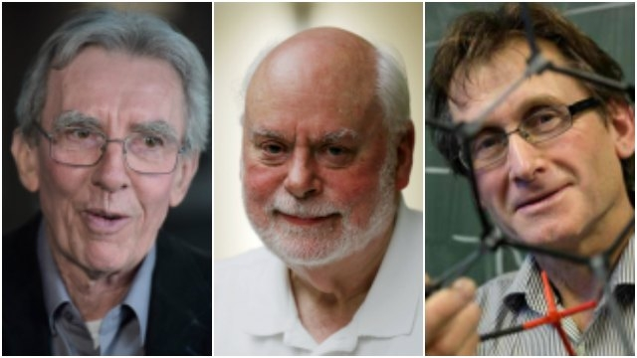
Photo credit:
http://www.dnaindia.com/scitech/report-nobel-prize-in-chemistry-2016-awarded-for-design-and-synthesis-of-molecular-machines-2261580

From Left to Right:
Jean-Pierre Sauvage, University of Strasbourg, France Sir J. Fraser Stoddart, Northwestern University, Evanston, IL, USA and Bernard L. Feringa, University of Groningen, the Netherlands

Nobel Prize awarded for
“Design and synthesis of molecular machines”
The first step towards a molecular machine was taken by Jean-Pierre Sauvage in 1983. Generally the molecules are joined by strong covalent bond in which the atoms share an electron or by ionic bond in which atom lose or gain electron. But, he linked two ring shaped molecule together to form a chain called catenane by mechanical bond.
The second step was taken by Fraser Stoddart in 1991, when he developed a rotaxane. He threaded a molecular ring onto a thin molecular axle and demonstrated that the ring was able to move along the axle. Among his developments based on rotaxanes are a molecular lift, a molecular muscle and a molecule-based computer chip.
Bernard Feringa was the first person to develop a molecular motor; in 1999 he got a molecular rotor blade to spin continually in the same direction. Using molecular motors, he has rotated a glass cylinder that is 10,000 times bigger than the motor and also designed a nanocar.

Reference:
https://www.nobelprize.org/nobel_prizes/chemistry/laureates/2016/press.html

Chemistry Nobel Laureate (2015)
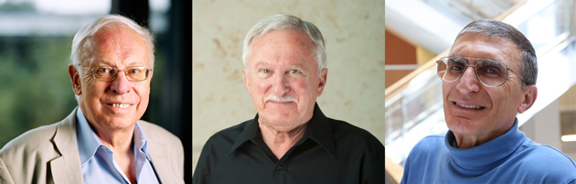
Photo credit:
http://www.rsc.org/eic/2015/10/2015-nobel-prize-dna-repair

From left to right:
Tomas Lindahl, Francis Crick Institute and Clare Hall Laboratory, Hertfordshire, UK, Paul Modrich Howard Hughes Medical Institute and Duke University School of Medicine, Durham, NC, USA and Aziz Sancar University of North Carolina, Chapel Hill, NC, USA
Nobel Prize awarded for
“Mechanistic studies of DNA repair"
The DNA in human cell undergoes several thousand to a million damaging events per day, generated by both external and internal metabolic activities. Changes in the genome can lead to error in DNA transcription. What these three laureates have investigated and described is the ways in which DNA repair mechanism takes place.
Lindalh in 1996, had successfully identified this repair mechanism in human DNA. He discovered that the enzyme glycosylase can cut out a mutated base from a DNA strand. A polymerase enzyme then fills in the gap in the DNA, correcting the error.
Aziz Sancar has mapped nucleotide excision repair, the mechanism that cells use to repair UV damage to DNA. People born with defects in this repair system will develop skin cancer if they are exposed to sunlight.
Paul Modrich has demonstrated how the cell corrects errors that occur when DNA is replicated during cell division. This mechanism, mismatch repair, reduces the error frequency during DNA replication by about a thousand fold.

Reference:
https://www.nobelprize.org/nobel_prizes/chemistry/laureates/2015/press.html

Chemistry Nobel Laureate (2014)
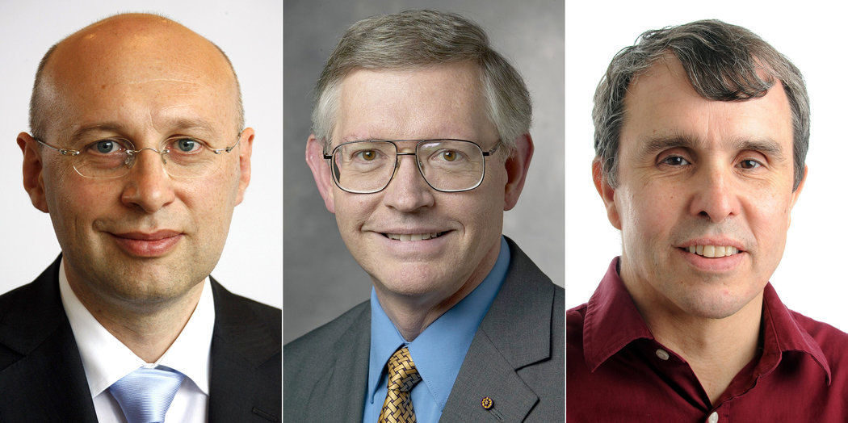
Photo credit:
http://www.nytimes.com/2014/10/09/science/nobel-prize-chemistry.html?_r=0

From left to right:
Stefan W. Hell, Max Planck Institute for Biophysical Chemistry, Göttingen, and German Cancer Research Center, Heidelberg, Germany William E. Moerner, Stanford University, Stanford, CA, USA and Eric Betzig
Janelia Research Campus, Howard Hughes Medical Institute, Ashburn, VA, USA.
Nobel Prize awarded for
“Development of high resolution microscope”

These three scientists share Nobel Prize for the development of super resolved fluorescence microscopy. The techniques they developed enabled extremely high resolution images using optical microscopy. They succeeded to overcome the diffraction limit i.e. the inability of light microscopy to distinguish between structures smaller than half the wavelength of visible light or about 200nm.Their new invention could visualize the structures within the cells of living organisms which is difficult by using electron microscopy.
Two separate principles are rewarded. One enables the method stimulated emission depletion (STED) microscopy, developed by Stefan Hell in 2000. Two laser beams are utilized; one stimulates fluorescent molecules to glow, another cancels out all fluorescence except for that in a nanometer-sized volume. Scanning over the sample, nanometer for nanometer yields an image with a better resolution.
Eric Betzig and William Moerner, working separately, laid the foundation for the second method, single-molecule microscopy. The method relies upon the possibility to turn the fluorescence of individual molecules on and off. Scientists image the same area multiple times, letting just a few interspersed molecules glow each time. Superimposing these images yields a dense super-image resolved at the nanolevel. In 2006 Eric Betzig utilized this method for the first time.
Today, nanoscopy is used world-wide and new knowledge of greatest benefit to mankind is produced on a daily basis.

Reference:
https://www.nobelprize.org/nobel_prizes/chemistry/laureates/2014/press.html

Chemistry Nobel Laureate (2013)
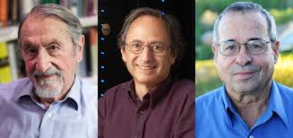
Photo credit:
http://blogs.ucl.ac.uk/chemdeptblog/2013/11/08/calculated-chemistry-nobel-prize-2013/

From left to right:
Martin Karplus, Université de Strasbourg, France and Harvard University, Cambridge, MA, USA. Michael Levitt, Stanford University School of Medicine, Stanford, CA, USA and Arieh Warshel, University of Southern California, Los Angeles, CA, USA

Nobel Prize awarded for
“Design and synthesis of Molecular machine”

Chemists used to create models of molecules using plastic balls and sticks. Today, the modeling is carried out in computers. In the 1970s, Martin Karplus, Michael Levitt and Arieh Warshel laid the foundation for the powerful programs that are used to understand and predict chemical processes. For instance, in simulations of how a drug couples to its target protein in the body, the computer performs quantum theoretical calculations on those atoms in the target protein that interact with the drug.
Today the computer is just as important a tool for chemists as the test tube. Simulations are so realistic that they predict the outcome of traditional experiments.

Reference:
https://www.nobelprize.org/nobel_prizes/chemistry/laureates/2013/press.html

Chemistry Nobel Laureate (2012)
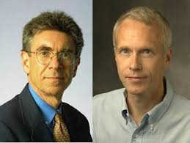

Photo credit: http://www.chemistryviews.org/details/ezine/2725471/Nobel_Prize_in_Chemistry_2012.html

From Left to Right
Robert J. Lefkowitz, Howard Hughes Medical Institute and Duke University Medical Center, Durham, NC, USA and Brian K. Kobilka
Stanford University School of Medicine, Stanford, CA, USA

Nobel Prize awarded for
“Study of G-protein–coupled receptors”

These two scientists are awarded Nobel Prize for their study of smart receptors
On cell surfaces: G-protein-coupled receptors. Their work helps explain how cells sense and respond to the changing environment around them, and in particular the role cell surfaces play in this process.
Lefkowitz started to use radioactivity in 1968 in order to trace cells' receptors. He attached an iodine isotope to various hormones, and he managed to unveil several receptors, among those a receptor for adrenalin: β-adrenergic receptor. The team achieved its next big step during the 1980s in which Kobilka isolated the gene that codes for the β-adrenergic receptor from the gigantic human genome.
Furthermore, in 2011, Kobilka achieved another break-through; he and his research team captured an image of the β-adrenergic receptor at the exact moment that it is activated by a hormone and sends a signal into the cell. This image is a molecular masterpiece – the result of decades of research.

Reference:
https://sputniknews.com/science/20121010176531598/
https://www.nobelprize.org/nobel_prizes/chemistry/laureates/2012/press.html

Chemistry Nobel Laureate (2011)
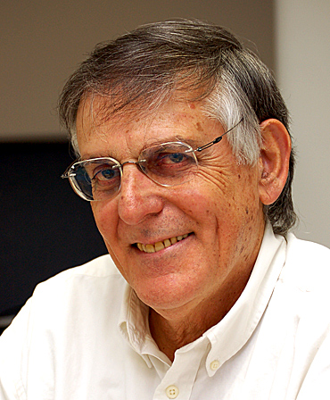
Photo credit:
http://archive.news.iastate.edu/news/2011/oct/dannynobel

Dan Shechtman, Technion - Israel Institute of Technology, Haifa, Israel

Nobel Prize awarded for
“The discovery of quasicrystals”
Generally in crystalline arrangement of an atom the particles arrange themselves in a definite pattern that repeats in all directions but in 2011 Dan Shechtman discovered a whole new category of crystals whose patterns don’t repeat in the traditional way.
He carefully examined a rapidly cooled metal alloy. He found that the atoms packed in this alloy were in a pattern that could not be repeated. He named these structures as quasicrystals.
The quasicrystals are found in almost every metal and these quasicrystals have an uneven structure which means they do not have obvious cleavage planes thereby making them particularly hard in nature and they are likely to be used in protective coatings and future alloys.

Reference:
https://www.nobelprize.org/nobel_prizes/chemistry/laureates/2011/press.html
Chemistry Nobel Laureate (2010)
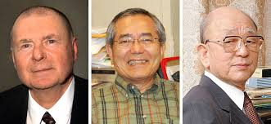
Photo credit:
http://nobel4.blogspot.in/2011/06/nobel-prize-in-chemistry-2010-to.html

From left to right:
Richard F. Heck, University of Delaware, Newark, DE, USA,Ei-ichi Negishi, Purdue University, West Lafayette, IN, USA and Akira Suzuki, Hokkaido University, Sapporo, Japan

Nobel Prize awarded for
"Palladium-catalyzed cross couplings in organic synthesis"

Organic chemistry is very importance. It is the study of life and all of the chemical reactions related to life. The development of palladium-catalyzed cross coupling has vastly improved the possibilities for chemists to create sophisticated chemicals, for example carbon-based molecules as complex as those created by nature itself.
To form complex chemicals the carbon atoms must join together. In order to create these complex chemicals, chemists need to be able to join carbon atoms together. In Palladium-catalyzed cross coupling, carbon atoms meet on a palladium atom, whereupon their proximity to one another kick-starts the chemical reaction.
Palladium-catalyzed cross coupling is used in research worldwide, as well as in the commercial production of for example pharmaceuticals and molecules used in the electronics industry.

Reference:
http://www.nobelprize.org/nobel_prizes/chemistry/laureates/2010/press.html

Chemistry Nobel Laureate (2009)
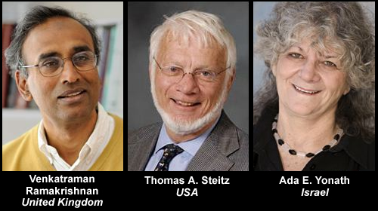
Photo credit:
http://mankabros.com/onmedea/2009/10/the-nobel-prize-for-chemistry.html
Nobel Prize awarded for
“Studies of the structure and function of ribosome.”

Ribosomes are the protein builder of the cell and they are also target for new antibiotics. These three scientists have used x ray crystallography technique to show the structure and function of ribosome at atomic level.
Based upon the information in DNA, ribosome’s make proteins such as oxygen-transporting hemoglobin, antibodies of the immune system, hormones such as insulin, the collagen of the skin, or enzymes that break down sugar. Ribosomes are also important target for new antibiotics because many of today's antibiotics cure various diseases by blocking the function of bacterial ribosomes. The three Laureates have all generated 3D models that show how different antibiotics bind to the ribosome which are now used by scientists in order to develop new antibiotics.

Reference:
http://www.nobelprize.org/nobel_prizes/chemistry/laureates/2009/press.html
Chemistry Nobel Laureate (2008)
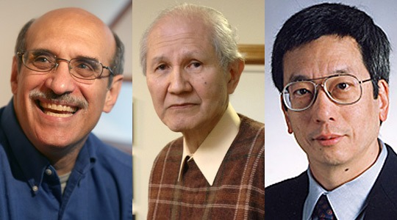
Photo credit:
http://home.sandiego.edu/~cloer/nobel08.html

From left to right:
Martin Chalfie, Columbia University, New York, NY, USA Osamu Shimomura, Marine Biological Laboratory (MBL), Woods Hole, MA, USA and Roger Y. Tsien, Howard Hughes Medical Institute,University of California,San Diego, La Jolla, CA, USA

Nobel Prize awarded for
“Discovery and development of the green fluorescent protein, GFP”
The remarkable brightly glowing green fluorescent protein, GFP, was first observed in the beautiful jellyfish, Aequorea victoria in 1962. With the aid of GFP, researchers have developed ways to watch processes that were previously invisible, such as the development of nerve cells in the brain or how cancer cells spread. This year's Nobel Prize in Chemistry rewards the initial discovery of GFP and a series of important developments which have led to its use as a tagging tool in bioscience. This glowing marker allows them to watch the movements, positions and interactions of the tagged proteins. Researchers can also follow the fate of various cells with the help of GFP. Examples such as nerve cell damage during Alzheimer's disease or how insulin-producing beta cells are created in the pancreas of a growing embryo.

Reference:
http://www.nobelprize.org/nobel_prizes/chemistry/laureates/2008/press.html

Chemistry Nobel laureate (2007)
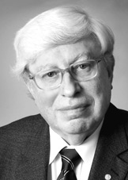
Photo credit:
https://www.nobelprize.org/nobel_prizes/chemistry/laureates/2007/

GerhardErtl Fritz-Haber-Institut der Max-Planck-Gesellschaft, Berlin, Germany

Nobel Prize awarded for
”Study of chemical processes on solid surfaces”
The Nobel Prize in Chemistry for 2007 is awarded for landmark studies in surface chemistry. This science is important for the chemical industry and can help us to understand such varied processes as why iron rusts, how fuel cells function and how the catalysts in our cars work. Chemical reactions on catalytic surfaces play a vital role in making industrial operations, such as the production of artificial fertilizer. Surface chemistry can even explain the destruction of the ozone layer, the different processes in the semiconductor industry. Professor Gerhard Ertl insights have provided the scientific basis of modern surface chemistry: his methodology is used in both academic research and the industrial development of chemical processes.
Reference:
http://www.nobelprize.org/nobel_prizes/chemistry/laureates/2007/press.html
Chemistry Nobel laureate (2006)
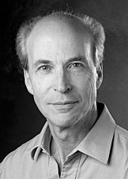
Photo credit:
https://www.nobelprize.org/nobel_prizes/chemistry/laureates/2006/
Roger D. Kornberg Stanford University, CA, USA

Nobel Prize awarded for
“Studies of the molecular basis of eukaryotic transcription"

In order for our bodies to make use of the information stored in the genes, a copy must first be made and transferred to the outer parts of the cells; this copying process is called transcription. Roger Kornberg was the first to create an actual picture of how transcription works at a molecular level in eukaryotes which are organisms whose cells have a well-defined nucleus like humans. If transcription stops, genetic information is no longer transferred into the different parts of the body and since these are then no longer renewed, the organism dies within a few days. Understanding of how transcription works also has a fundamental medical importance. Disturbances in the transcription process are involved in many human illnesses such as cancer, heart disease and various kinds of inflammation.

Reference:
http://www.nobelprize.org/nobel_prizes/chemistry/laureates/2006/press.html
Chemistry Nobel laureate (2005)
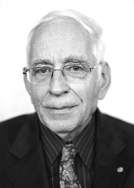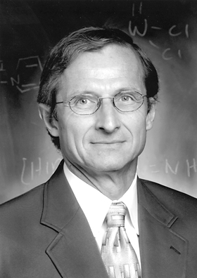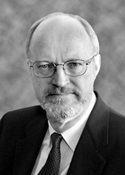
Photo credit:
https://www.nobelprize.org/nobel_prizes/chemistry/laureates/2005/
From left to right:
Yves Chauvin Institut Français du Pétrole, Rueil-Malmaison, France,Robert
H. Grubbs California Institute of Technology (Caltech), Pasadena, CA, USA
and Richard R. SchrockMassachusetts Institute of Technology (MIT),
Cambridge, MA, USA

Nobel Prize awarded for
“The development of the metathesis method in organic synthesis”

This year's Nobel Prize Laureates in chemistry have made metathesis into one of organic chemistry's most important reactions. Many opportunities have been created for producing many new molecules like for example in pharmaceuticals. The word metathesis means 'change-places'. In metathesis reactions, double bonds are broken and made between carbon atoms in ways that cause atom groups to change places. This happens with the assistance of special catalyst molecules. These Nobel laureates were able to explain in detail how metatheses reactions function and what types of metal compound act as catalysts in the reactions, they have even produced an efficient metal-compound catalyst for methasesis which are stable in air and have numerous applications.

Reference:
http://www.nobelprize.org/nobel_prizes/chemistry/laureates/2005/press.html

Chemistry Nobel Laureate (2004)

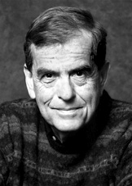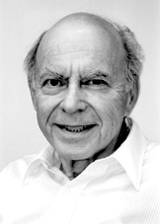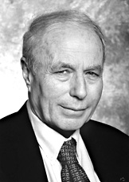

Photo credit:

https://www.nobelprize.org/nobel_prizes/chemistry/laureates/2005/

From left to right:
Aaron CiechanoverTechnion - Israel Institute of Technology, Haifa, Israel,
Avram HershkoTechnion - Israel Institute of Technology, Haifa, Israel and
Irwin RoseUniversity of California, Irvine, USA

Nobel prize awarded for
“The discovery of ubiquitin-mediated protein degradation”

They have discovered one of the cell's most important process protein degradation. The cell functions as a highly-efficient checking station where proteins are built up and broken down at a furious rate. It is now possible to understand at molecular level how the cell controls a number of central processes by breaking down certain proteins and not others. Examples: cell division, DNA repairs, quality control of newly-produced proteins etc.

Reference:
https://www.nobelprize.org/nobel_prizes/chemistry/laureates/2004/press.html
Chemistry Nobel Laureate (2003)
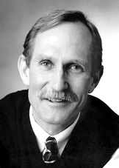
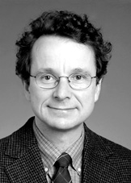

Photo credit:
https://www.nobelprize.org/nobel_prizes/chemistry/laureates/2003/

From left to right:
Peter Agre Johns Hopkins University School of Medicine, Baltimore, USA; Roderick MacKinnon Howard Hughes Medical Institute, The Rockefeller University, New York, USA

Nobel Prize awarded for
“The discovery of water channels” and one half of the prize to “Structural and mechanistic studies of ion channels”.

This year rewards two scientists whose discoveries have clarified how salts (ions) and water are transported out and into the cells of the body. For example, the kidneys recover water from primary urine and how the electrical signals in our nerve cells are generated and propagated. This is of great importance for our understanding of many diseases of e.g. the kidneys, heart, muscles and nervous system. This illustrates how biochemistry reaches down to the atomic level in its quest to understand the fundamental processes of life.

Reference:
https://www.nobelprize.org/nobel_prizes/chemistry/laureates/2003/press.html
Chemistry Nobel Laureate (2002)
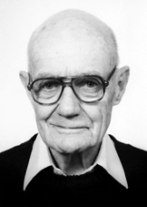
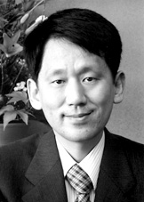
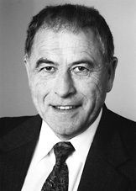
Photo credit:
https://www.nobelprize.org/nobel_prizes/chemistry/laureates/2002/

From left to right:
John B. FennVirginia Commonwealth University, Richmond, USA, and Koichi TanakaShimadzu Corp., Kyoto, Japan and the other half to
Kurt Wüthrich Swiss Federal Institute of Technology (ETH), Zürich, Switzerland and The Scripps Research Institute, La Jolla, USA
Nobel Prize awarded for
“Development of soft desorption ionization methods for mass spectrometric analyses of biological macromolecules”

This year’s Nobel Prize in Chemistry concerns powerful analytical methods such as mass spectrometry, nuclear magnetic resonance, electron spray ionization and soft laser desorption for studying biological macromolecules, for example proteins. The possibility of analyzing proteins in detail has led to increased understanding of the processes of life. Researchers can now rapidly reveal what different proteins a sample contains. They can also determine three-dimensional pictures showing what protein molecules look like in solution and can then understand their function in the cell. The methods have revolutionized the development of new pharmaceuticals, foodstuff control and early diagnosis of breast cancer and prostate cancer.

Reference:
https://www.nobelprize.org/nobel_prizes/chemistry/laureates/2002/press.html

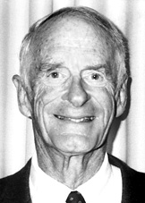
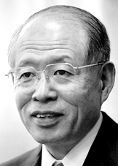
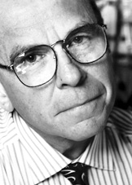
Chemistry Nobel Laureate (2001)

Photo credit:
https://www.nobelprize.org/nobel_prizes/chemistry/laureates/2001/

From left to right:
William S. Knowles St Louis, Missouri, USA, Ryoji Noyori
Nagoya University, Chikusa, Nagoya, Japan, and the other half to K. Barry Sharpless, The Scripps Research Institute, La Jolla, California, USA
Nobel Prize awarded for,
"Work on chirally catalyzed oxidation reactions"

William S. Knowles discovered that it is possible to use transition metals to make chiral catalysts for an important type of reaction called hydrogenation, thereby obtaining the desired mirror image form as the final product. His research quickly led to an industrial process for the production of the L-DOPA drug which is used in the treatment of Parkinson's disease. Ryoji Noyori has led the further development of this process to today's general chiral catalysts for hydrogenation. K. Barry Sharpless is awarded half of the Prize for developing chiral catalysts for another important type of reaction i.e. oxidation.

Reference:
https://www.nobelprize.org/nobel_prizes/chemistry/laureates/2001/press.html
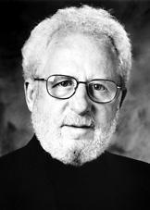
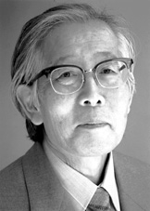
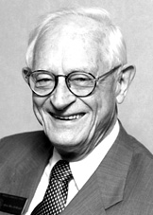
Chemistry Nobel Laureate (2000)
Photo credit:
https://www.nobelprize.org/nobel_prizes/chemistry/laureates/2000/

From Left to right:
Alan J. Heeger University of California at Santa Barbara, USA,Alan G. MacDiarmid University of Pennsylvania, Philadelphia, USA,Hideki ShirakawaUniversity of Tsukuba, Japan

Nobel Prize awarded for
“Discovery and development of conductive polymer

Polymers are those chemical compounds which contain repeated units of molecule. Mostly polymer do not conduct electricity but if it contains alternate single and double bonds between the carbon atoms and doping material than it becomes conductor which are used as anti-static substances for photographic film, shields for computer screen against electromagnetic radiation . In addition, semi-conductive polymers have recently been developed in light-emitting diodes, solar cells and as displays in mobile telephones and television screens.

Reference:
https://www.nobelprize.org/nobel_prizes/chemistry/laureates/2000/press.html

