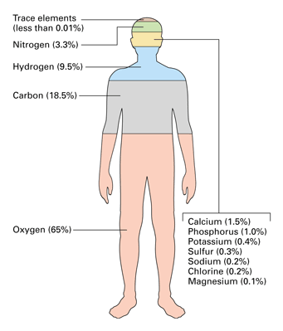
Out of 118 elements known to us 24 elements are essential for human life. Depending upon the need, they are classified into different categories as shown below. The top four elements make around 94% of body weight. Major elements and trace elements are required in only very small amounts, but they do play a very important role in keeping the body working effectively.

Elements in Human Body
Top four elements
Major Elements
Trace Elements
C, H, O, N
Ca, P, K, S, Na, Mg, Cl
B, Cr, I, Fe, Co, Mn, Si, Cu, Mo, Sn, F, Se, V
Photo credit: https://www.quora.com/Why-do-toe-nails-contain-so-much-gold
Elements in Human body

Most of the human body is made up of cells consisting of 65-90% water by weight. Therefore, it isn't surprising that most of a human body's mass is oxygen. Carbon, the basic unit for organic molecules, comes in second. 99% of the mass of the human body is made up of just six elements: oxygen (65%), carbon (18%), hydrogen (10%), nitrogen (3%), calcium (1.5%), and phosphorus (1.0%) The other elements which are present in minor quantities are potassium (0.35%), sulfur (0.25%), sodium (0.15%), magnesium (0.05%), iron (0.70%), copper, zinc, selenium, molybdenum, fluorine, chlorine, iodine, manganese, cobalt.

The functions of the different elements present in the human body are as follows-

Oxygen
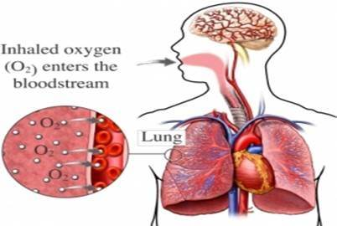
Atomic No | 8
Electronic configuration | 1s² 2s² 2p⁴
Group | 16
Period | 2
Category | Non metal

Biological role:
The heme group present in hemoglobin binds with oxygen and transport it from lungs to tissues. Molecular oxygen is essential for cellular respiration in all organisms. It is used as an electron acceptor in mitochondria present in the cell to generate chemical energy in the form of Adenosine triphosphate (ATP).

Carbon
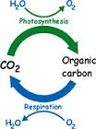
Atomic No | 6
Electronic configuration | 1s² 2s² 2p²
Group | 4
Period | 2
Category | Non metal

Biological role :
All organic molecules (fats, proteins, carbohydrates, nucleic acids) contain carbon. It also exists in the form of carbon dioxide which is exhaled during respiration process. It is the second most abundant element in human body.

Hydrogen
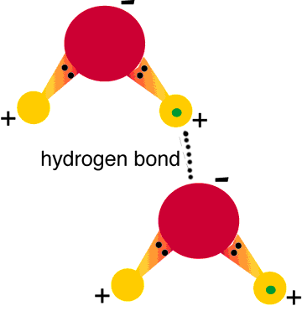
Atomic No | 1
Electronic configuration | 1s¹
Group | 1
Period | 1
Category | Non metal

Biological role:
Most of the hydrogen in the body is bound with oxygen to form water, H₂O. Hydrogen, like carbon, is found in every single organic molecule in the body. It also acts as a proton or positive ion in chemical reactions. Hydrogen bond is present in most of the macromolecules.
Nitrogen
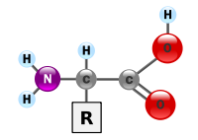
Atomic No | 7
Electronic configuration | 1s² 2s² 2p³
Group | 15
Period | 2
Category | Non metal

Biological role:
Nitrogen is an essential building block of all amino and nucleic acids, essential to life on Earth. Elemental nitrogen in the atmosphere cannot be used directly by either plants or animals, and must convert to a reduced state in order to be useful for higher plants and animals.

Calcium
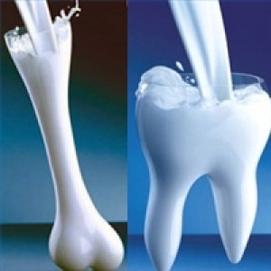
Atomic No | 20
Electronic configuration | [Ar] 4s²
Group | 2
Period | 4
Category | Alkaline earth metal

Biological role :
Human body uses 99 percent of its calcium to keep bones and teeth strong. It also plays key roles in cell signaling, blood clotting, muscle contraction and nerve function. Cells use calcium to activate certain enzymes, transport ions across the cellular membrane, and send and receive neurotransmitters during communication with other cells.
http://healthyeating.sfgate.com/role-calcium-bodys-nutrition-1265.html
Phosphorus
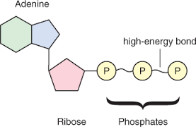
Atomic No | 15
Electronic configuration | [Ne] 3s² 3p³
Group | 15
Period | 3
Category | Non metal

Biological role:
It is a principle material of bones and teeth. Phosphorus is found in the form of the phosphate PO₄³⁻ plays a major role in biological molecules such as DNA and RNA where it forms part of the structural framework of these molecule. It is found in muscles, blood and nerves.

Potassium
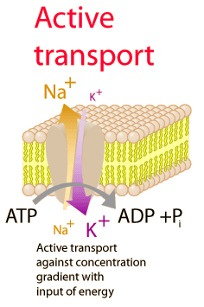
Atomic No | 19
Electronic configuration | [[Ar] 4s¹
Group | 1
Period | 4
Category | Metal

Biological role:
Potassium is a very significant body mineral, important to both cellular and electrical function. It is one of the main blood minerals called "electrolytes" (the others are sodium and chloride), which means it carries a tiny electrical charge (potential). It regulates the water balance and the acid-base balance in the blood and tissues.

Sulfur
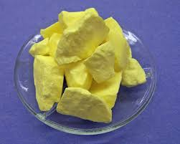

Atomic No | 16
Electronic configuration | [Ne] 3s² 3p⁴
Group | 16
Period | 3
Category | Non metal

Biological role : Thiamin
It is the essential element in amino acids methionine and cysteine. Sulphur is also involved in cellular respiration and helps the cells use oxygen efficiently. It is also present in keratin protein which forms hair and nails.

Sodium
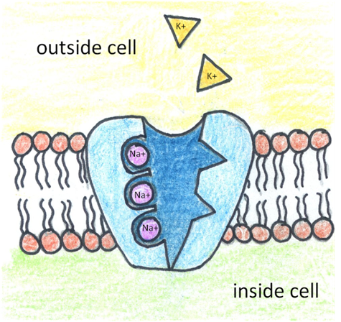

Atomic No | 11
Electronic configuration | [Ne] 3s¹
Group | 1
Period | 3
Category | Metal

Biological role:
In sodium-potassium pump found in the plasma membrane of cells, sodium is pumped out and potassium is pumped in against concentration gradient. It is important for physiology of cell. For example, nerve conduction.

Magnesium
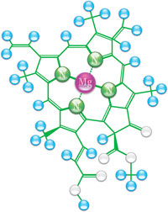
Atomic No | 12
Electronic configuration | [Ne] 3s²
Group | 1
Period | 3
Category | Alkaline earth metal

Biological role:
This element regulates over 300 biochemical reactions in human body through role as enzyme co factor. Without magnesium muscles will be in a permanent state of contractions. It plays a vital role in the reaction that generates and use ATP.
.
.

Copper
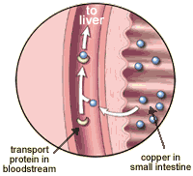
Atomic No | 29
Electronic configuration | [Ar] 3d¹⁰ 4s¹
Group | 11
Period | 4
Category | Transiton metal

Biological role:
Copper is a metal that works with iron to form healthy red blood cells. It helps to produce energy in cells and form a protective covering of nerves and connective tissues.

Zinc
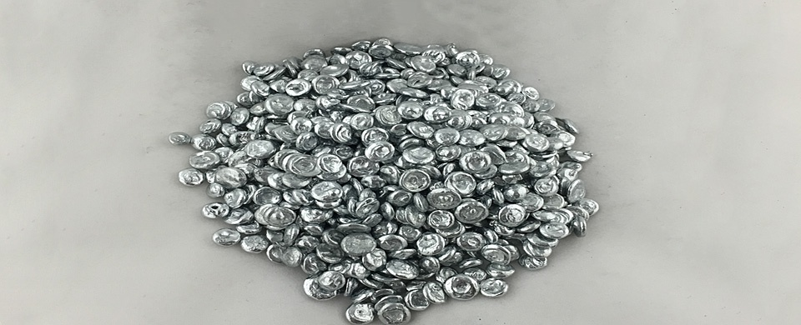
Atomic No | 30
Electronic configuration | [Ar] 3d¹⁰ 4s²
Group | 12
Period | 4
Category | Transiton metal

Biological role:
Normalizes the exchange of protein, carbohydrate, and phosphoric substances. Regulates the activity of the reproductive system; Contributes to the quick healing of the wounds; Contributes to body growth and improves taste and smell perception.

Selenium
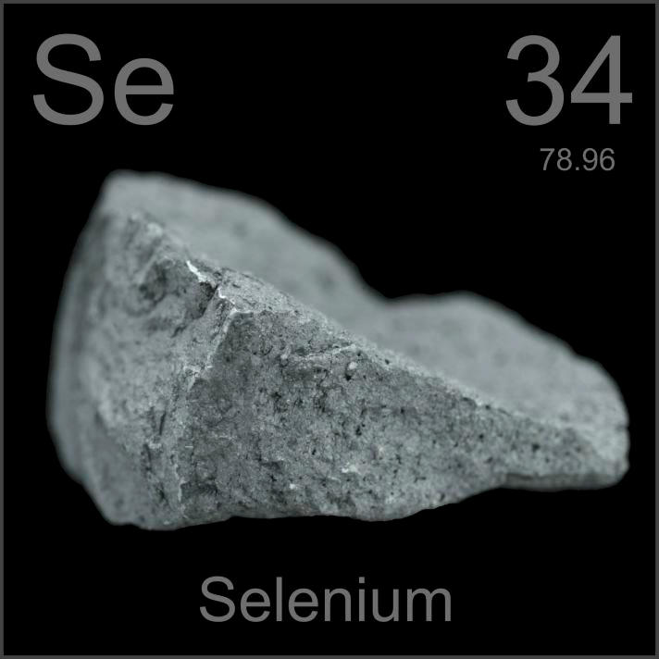
Atomic No | 34
Electronic configuration | [Ar] 3d¹⁰ 4s² 4p⁴
Group | 12
Period | 4
Category | Non metal

Biological role :
Selenium is used in the human body to form selenoproteins which are antioxidants.This nutrient is an important part of antioxidant enzymes that protect cells against the effects of free radicals that are produced during normal oxygen metabolism. It is also essential for normal functioning of the immune system and thyroid gland.

Molybdenum
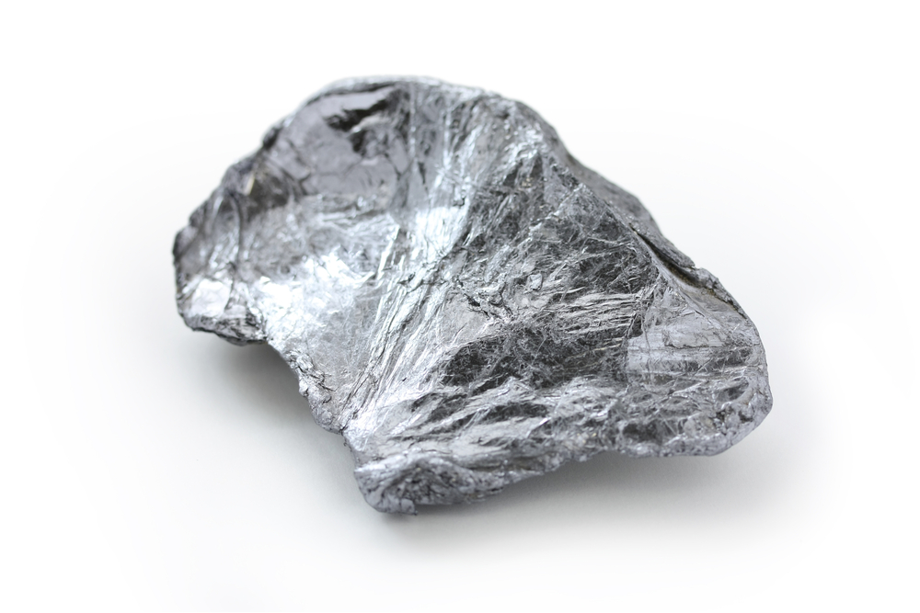
Atomic No | 42
Electronic configuration | [Kr] 4d⁵ 5s¹
Group | 6
Period | 5
Category | Transition metal

Biological role :
The main known function of molybdenum in humans is to act as a catalyst for enzymes and to help facilitate the breakdown of certain amino acids in the body. It combines with sulfite oxidase to catalyze sulfur-containing amino acids that are crucial for human health.
Fluorine
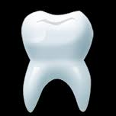
Atomic No | 9
Electronic configuration | 1s² 2s² 2p⁵
Group | 17
Period | 2
Category | Non metal

Biological role :
Well recognized for its role in forming bones and teeth, fluoride is present in the body as calcium fluoride. Fluoride hardens tooth enamel, reduces incidence of tooth decay and may prevent bone loss.
Chlorine
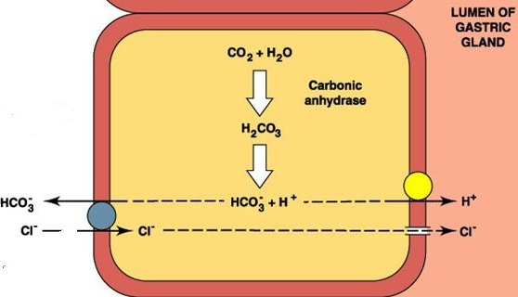

Atomic No | 17
Electronic configuration | [Ne] 3s² 3p⁵
Group | 17
Period | 3
Category | Non metal

Biological role :
Chlorine in the body is present in the form of soluble salts - chlorides. Most of our chloride comes from sodium chloride in food. Chloride ions helps keep the amount of fluid inside and outside of cells in balance. It also helps maintain proper blood volume, blood pressure, and pH of body fluids.

Iodine
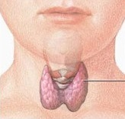
Atomic No | 53
Electronic configuration | [Kr] 4d¹⁰ 5s² 5p⁵
Group | 17
Period | 5
Category | Non metal

Biological role : Goitre
Iodine is critical for formation of thyroid hormones T3, T4 or thyroxine. Inadequate production of thyroid hormones can cause enlargement of the thyroid gland, also known as goiter, while its deficiency during pregnancy can cause irreversible brain damage in newborns.

Manganese
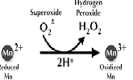
Atomic No | 25
Electronic configuration | [Ar] 4s² 3d⁵
Group | 11
Period | 4
Category | Transiton metal

Biological role :
Manganese is contained in the enzyme superoxide dismutase which is one of the important enzyme that deals with the toxic effect of superoxide (1 electron reduction of oxygen) present in the body.

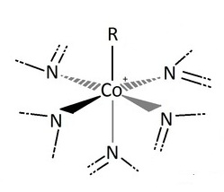
Cobalt

Atomic No | 27
Electronic configuration | [Ar] 3d⁷ 4s²
Group | 9
Period | 4
Category | Transiton metal

Biological role :
Cobalt is the important component of the vitamin cobalamin, B₁₂. It plays as a vital part in stimulating numerous enzymes; helps build red blood cells and co-operates in iron absorption.

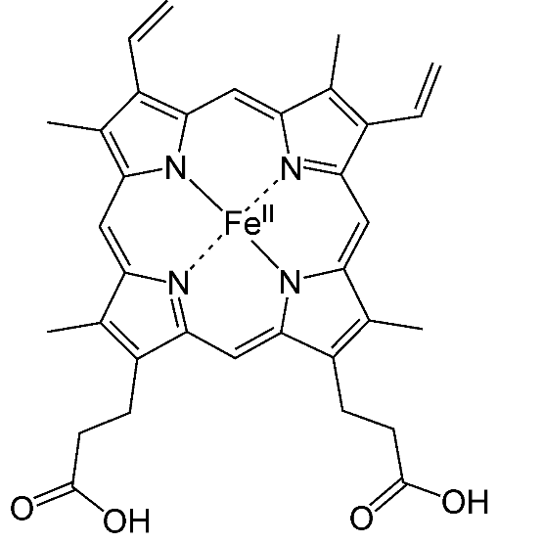
Iron

Atomic No | 26
Electronic configuration | [Ar] 3d⁶ 4s²
Group | 9
Period | 4
Category | Transiton metal

Biological role :
As a component of hemoglobin in blood, one of the most important functions of iron is to transport oxygen from the lungs to different parts of the body. In myoglobin, it enables storage of oxygen in muscle cells. It is also part of many enzymes and is essential for growth, healing, immune function and synthesis of DNA

References:
http://chemistry.about.com/cs/howthingswork/f/blbodyelements.htm

Photo credit:

Co - http://www.mikeblaber.org/oldwine/BCH4053/Lecture33/Lecture33.htm
Fe - https://en.wikipedia.org/wiki/Heme
O - https://www.quora.com/Does-the-oxygen-we-inhale-disappear-in-our-body
C - http://www.rapid.ac.uk/abc/bg/bcp.php
H - http://academic.brooklyn.cuny.edu/biology/bio4fv/page/hydroge.htm
N - https://en.wikipedia.org/wiki/Amino_acid
Ca - http://www.healthy-options.com/calcium-are-you-getting-enough/
Mn - http://pubs.rsc.org/en/content/chapterhtml/2014/bk9781849739436-00001?isbn=978-1-84973-943-6
P - http://scienceaid.co.uk/biology/biochemistry/atp.html
K - http://hyperphysics.phy-astr.gsu.edu/hbase/Biology/nakpump.html
S - http://science-yhairblog.blogspot.in/2012/02/sulfur-magical-hair-growth-potion-or.html
Na - http://science-yhairblog.blogspot.in/2012/02/sulfur-magical-hair-growth-potion-or.html
Mg - http://www.ancient-minerals.com/magnesium-benefits/what-is-function/
Cu - http://resources.schoolscience.co.uk/CDA/14-16/biology/copch1pg2.html
Zn - http://www.neymetals.com/product/zinc/
Se - http://www.periodictable.com/Items/034.12/index.html
Mo - http://kingofwallpapers.com/molybdenum.html
F - http://tophdimgs.com/460789-tooth.html
Cl - http://slideplayer.com/slide/4039124/
I - https://ljkboerner.wordpress.com/2011/03/12/why-give-iodide-for-radiation-poisoning/

